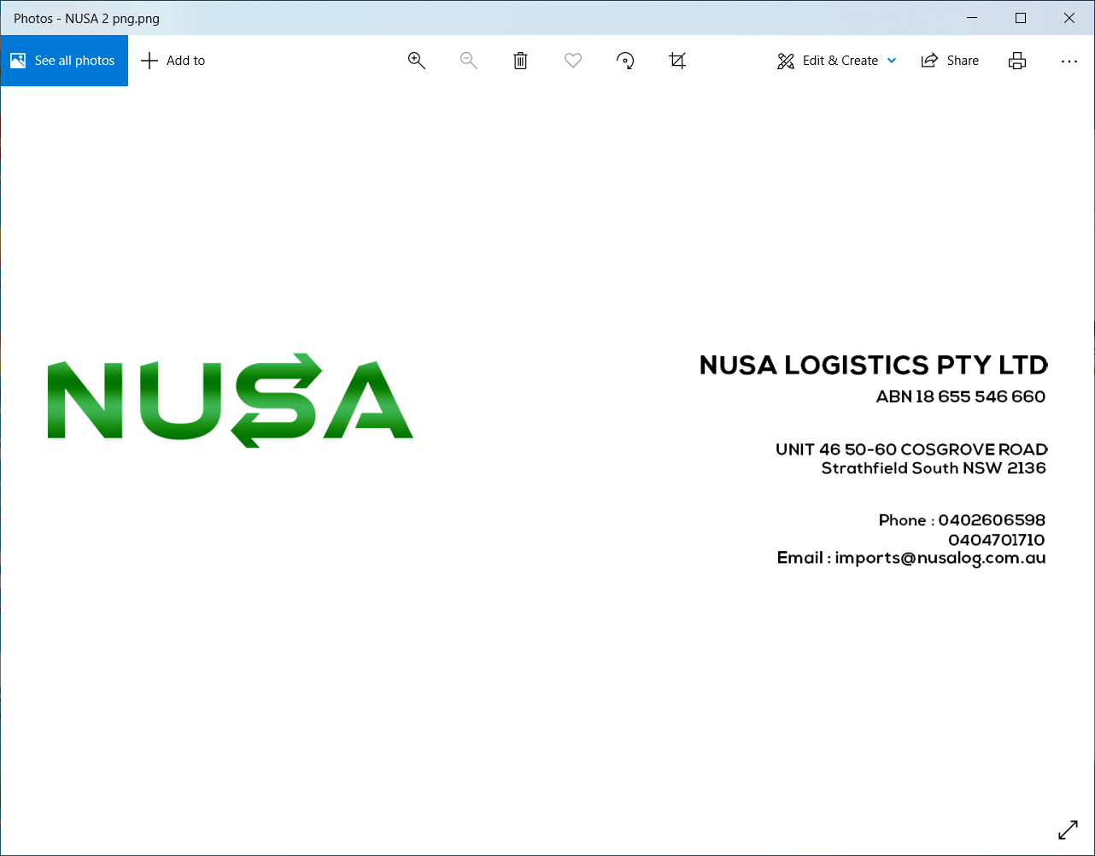

FCL – SOLAS – Verified Gross Mass (VGM) Declaration

In order to comply with the SOLAS regulation (effective July 1, 2016), please declare the verified gross mass information by completing this form, either in CAPITALS or preferably typed:

Nusa Logistics Booking Number
Carrier Booking Number (optional)
Total Number Of Containers | 1

Container Number | Seal Number | Weighting  Method*  1 or 2 | Verified  Gross Mass  (VGM) | VGM – Unit  Of Measure  (KGS or Lbs) | Date of Weighting  (DD/MM/YY)
 |  | 2 |  | KGS

*Please define weight method:
Weighing Method 1: By weighing the stuffed container using calibrated and certified equipment approved by the designated authority of the country in which packing of the container was completed.

Weighing Method 2: By weighing all packages, pallets, dunnage, securing material, etc that have been packed into the container and by adding the tare weight of the container to the sum of the single weights, using a certified method approved by the assigned authority of the country in which packing of the container was completed.

Shipper’s Company Name (as shown on B/L)
Shipper’s Address (as shown on B/L)
Signature and Name in CAPITALS
(If electronic Signature: please specify name in CAPITALS)
Date (DD/MM/YY) and Time

We, the shipper, hereby warrant to Nusa Logistics Pty Ltd and affiliates that the information provided in this form is accurate and complete and according to the requirements of the international convention for safety of life at sea (SOLAS, link: https://www.worldshipping.org/industry-issues/safety/SOLAS_CHAPTER_VI_Regulations_2_Paragraphs_4.6.pdf).
We further agree to indemnify and hold Nusa Logistics Pty Ltd harmless from any claims, damages, losses, penalties or expenses resulting from the incompleteness or inaccuracy of the information herein provided.

